***Davis Data Science Club***

*Spring 2023*

*Sign Language Detection*

**\*\*Following this Reference\*\***

Real Time Sign Language Detection: <https://youtu.be/pDXdlXlaCco>

We’ll be using Jupyter notebooks for this project, so if you don’t have it please download it and create an account if needed. I use Anaconda to access Jupyter Notebooks you could do anyway you like.

**Cloning Git Repository:**

1. Make a new folder, “SLD”, on your Desktop.
2. Now, Go to Command Prompt and clone the following git repository:

<https://github.com/nicknochnack/RealTimeObjectDetection.git>



Should be like this^

Note: Idk why but the cloning was slow for me. Maybe be cause I was using library wifi

By the end of the cloning you should have 1 Folder called: “RealTimeObjectDetection”. Inside that you should find:

1. Folder: “Tensorflow” -> 2 Folders: “scripts” and “workspace”: scripts-> python script: “generate_tfrecord”

Workspace -> 4 folders: “annotations”, “images”, “models”, “pre-trained-models” and so on..

1. Jupyter file: “Tutorial”

**Collecting Images**

Create a new Python 3 file under the RealTimeObjectDetection folder. You should have something like this:

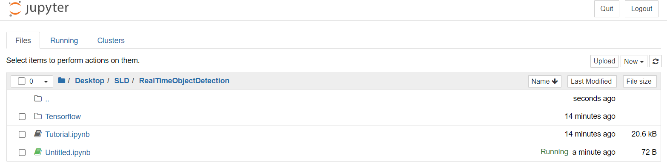

Make sure to make it under Desktop->SLD->RealTimeObjectDetection

Import 4 dependencies: opencv, uuid, os, and time